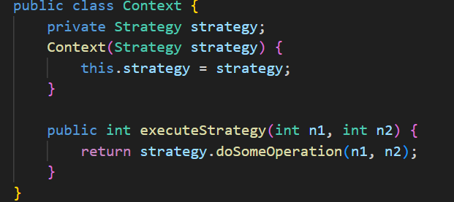

Single Responsibility and Open/Closed Principle Is used here.

Strategy

Concrete Strategy Class

Context

Client Code

